# KOPPEN CLIMATE CLASSIFICATIONS: Brief Notes

## Introduction:

The Koppen Climate Classification aims to describe and classify different biomes in a systematic fashion [1]. It has been used for more than 100 years to describe various environmental conditions through the usage of multiple variables focused around temperature and precipitation. There are five primary classifications: Tropical (A), Arid (B), Temperature (C), Cold (D), and Polar (E). Each primary classification has multiple secondary sub-classifications, with tertiary classifications used as needed.

## Classifications:

Table from [1]. Do not use without properly citing.

## US/North American Classifications

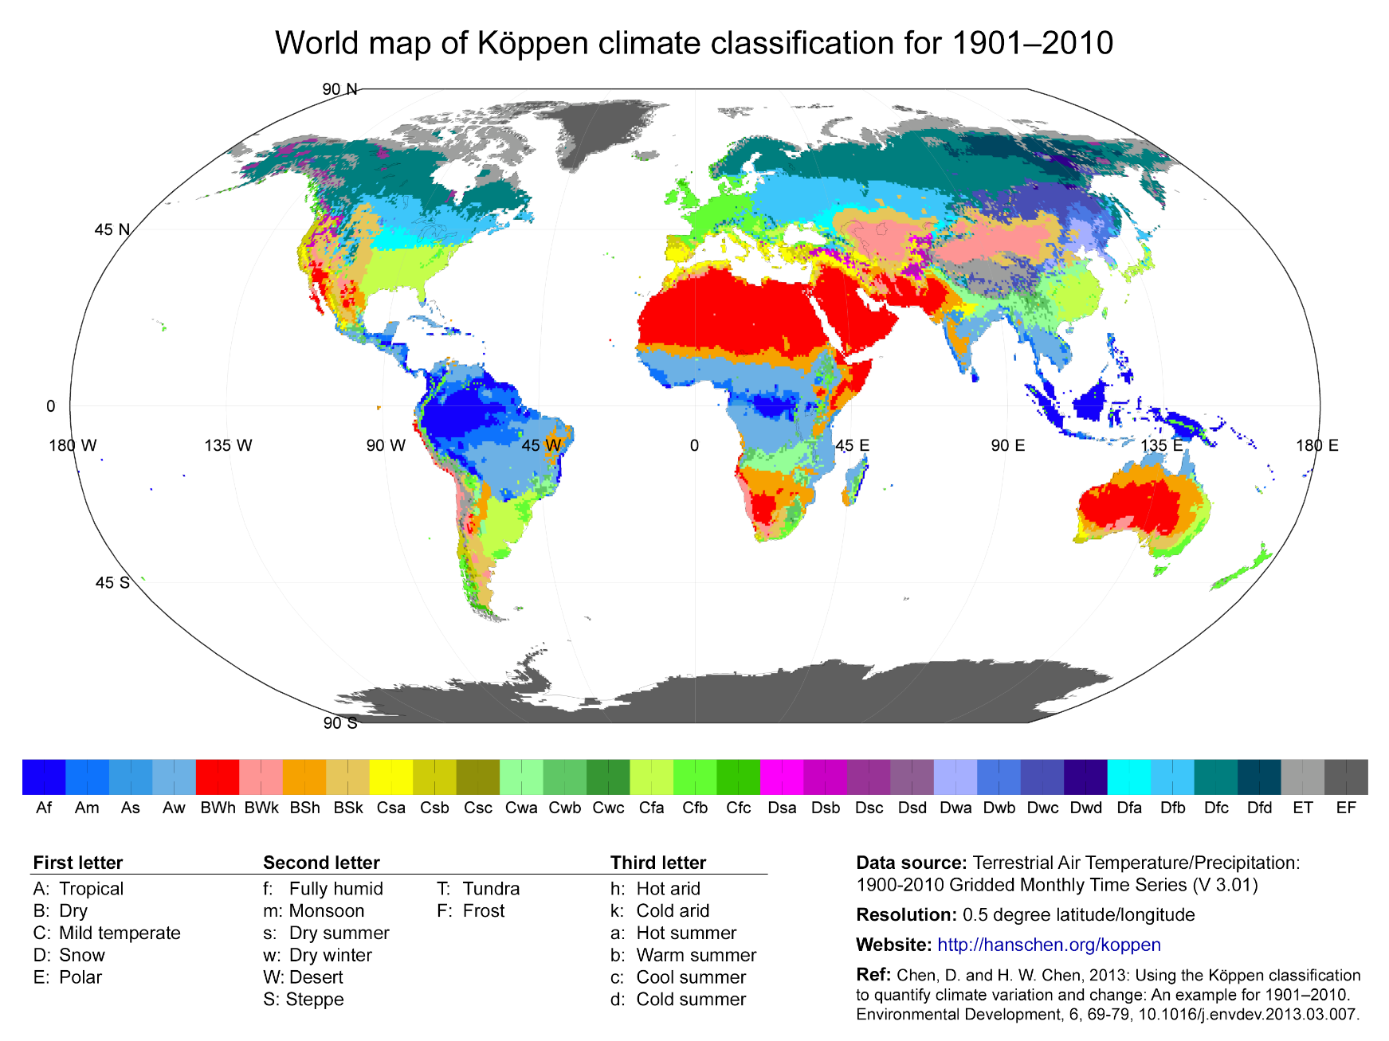

## Regions to use for Study:

1. Ashland, Wisconsin **(Dfb)**
   1. Reasonably remote, near significant natural resources. Close to American Indigenous lands, which may be interested in remote grid operations.
2. Midland, Texas (**BSh)**
   1. Western Texas oil region. Gas projects are typically remote and therefor candidates for a microreactor.
3. Blaine County Montana (**BSk)**
   1. Remote, low population county in Montana. Houses an American Indigenous reservation.
4. West Central Oregon (**Csb)**
   1. Multiple remote logging operations, farming, mountains. Oregon State University is also here (Benton County).
5. Eielson AFB (**Dfc)**
   1. Popular location to study, a good benchmark. Already has a microreactor planned (in theory).
6. New Orleans, LA **(Cfa)**
   1. Hot tropical location along the Gulf of Mexico. Prone to severe natural disasters (Hurricane Katrina), could be an interesting case for emergency microreactor power supplies.